1. import Facebook SDK ( download your own, or use mine, I already have one checked in in github)

1.1) eclipse -> import from git, import github.com/jljacoblo/cs595, you can import all of the projects, but it will be messy, ONLY import Facebook SDK

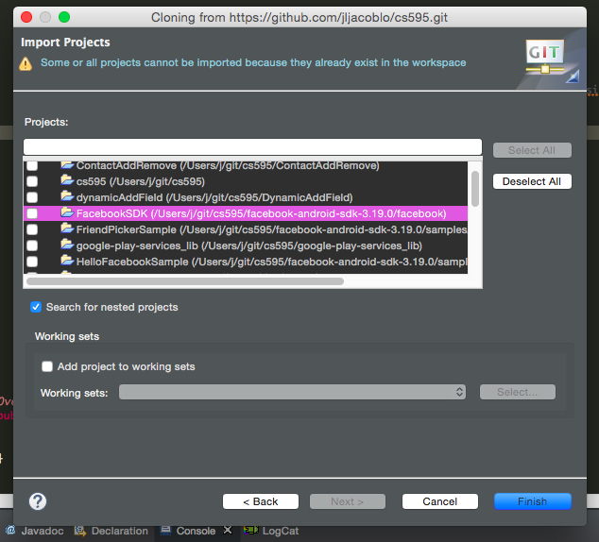

1. in testApp1, import the Facebook SDK library project

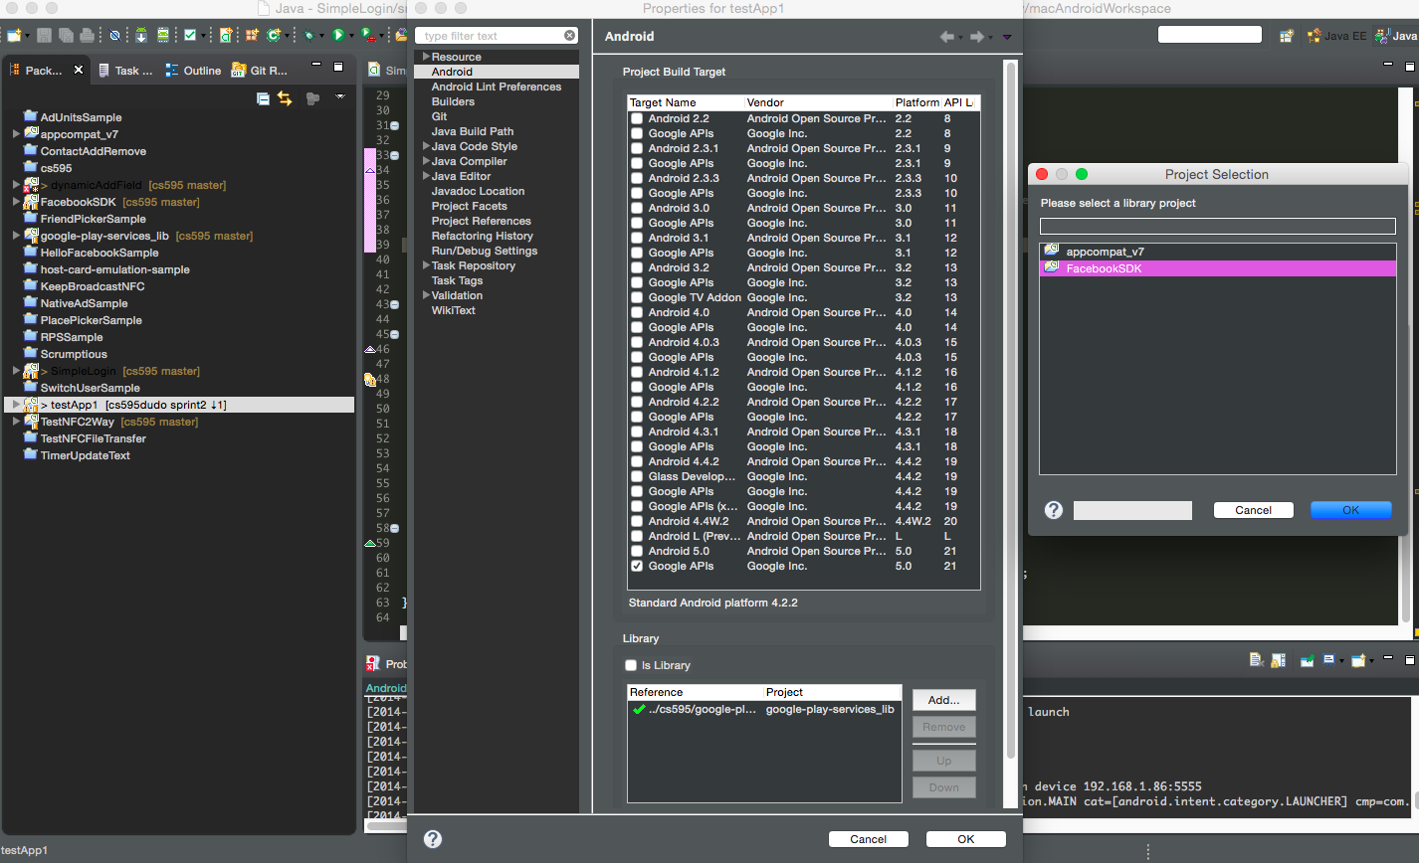

1. update res/values/strings.xml, add:

<string name="app_id">364340013746080</string>

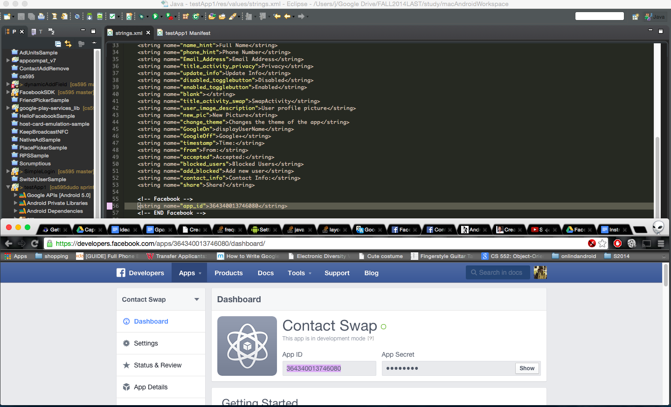

1. update Android Manifest, add one more activity inside <application>

<activity android:name="com.facebook.LoginActivity"

android:theme="@android:style/Theme.Translucent.NoTitleBar"

android:label="@string/app_name" />

<meta-data android:name="com.facebook.sdk.ApplicationId" android:value="@string/app_id"/>

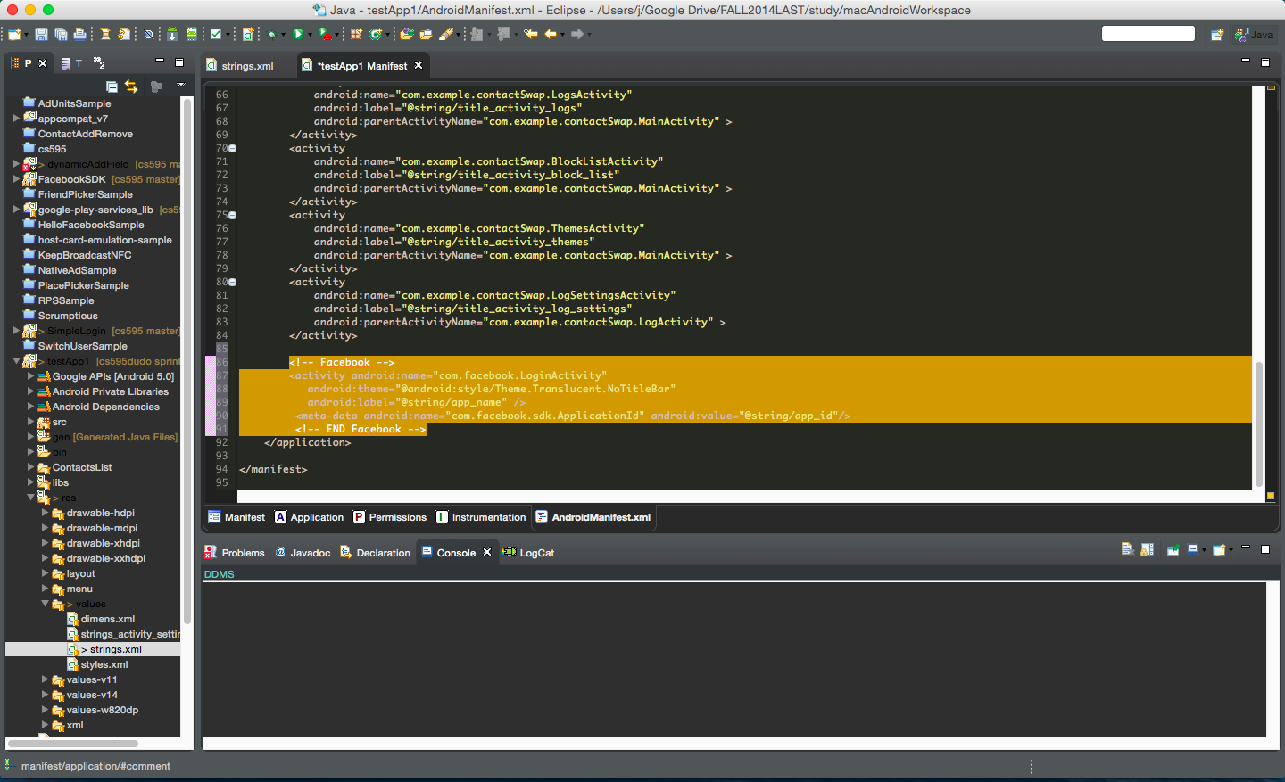

1. update activity_privacy.xml, add the Facebook Login button

<TableRow>

<com.facebook.widget.LoginButton

android:id="@+id/authButton"

android:layout_width="50dp"

android:layout_height="50dp"

android:layout_alignParentTop="true"

android:layout_centerHorizontal="true"

android:layout_marginTop="0dp"

android:minWidth="64dip" />

</TableRow>

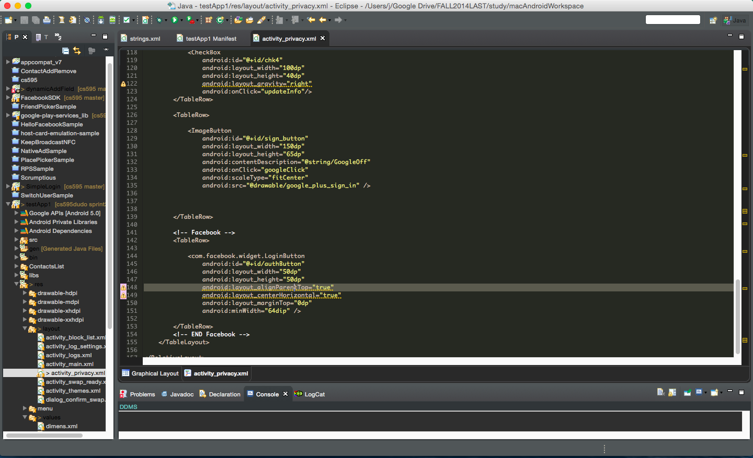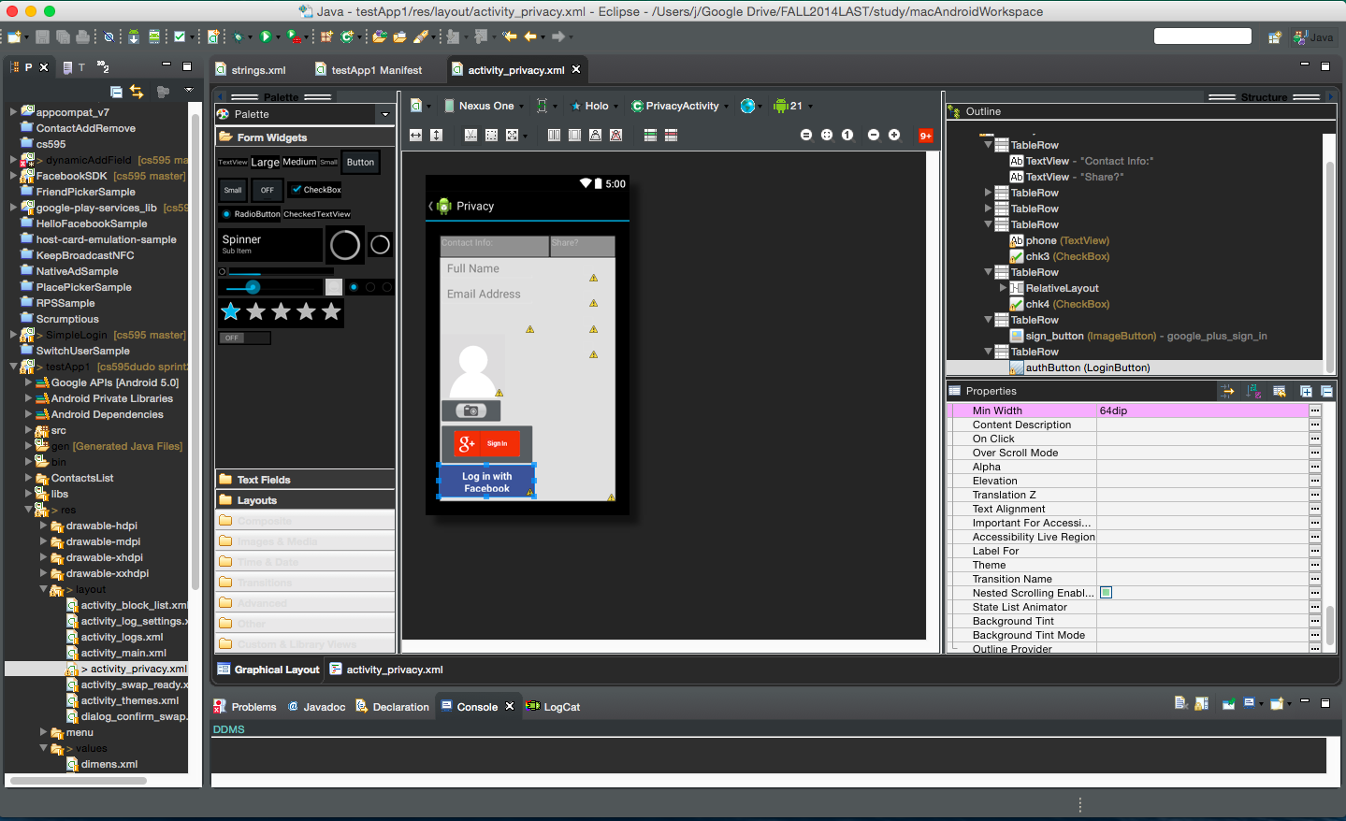

1. update privacyActivity.java, import

import com.facebook.Request;

import com.facebook.Response;

import com.facebook.Session;

import com.facebook.SessionState;

import com.facebook.model.GraphUser;

import com.facebook.widget.LoginButton;

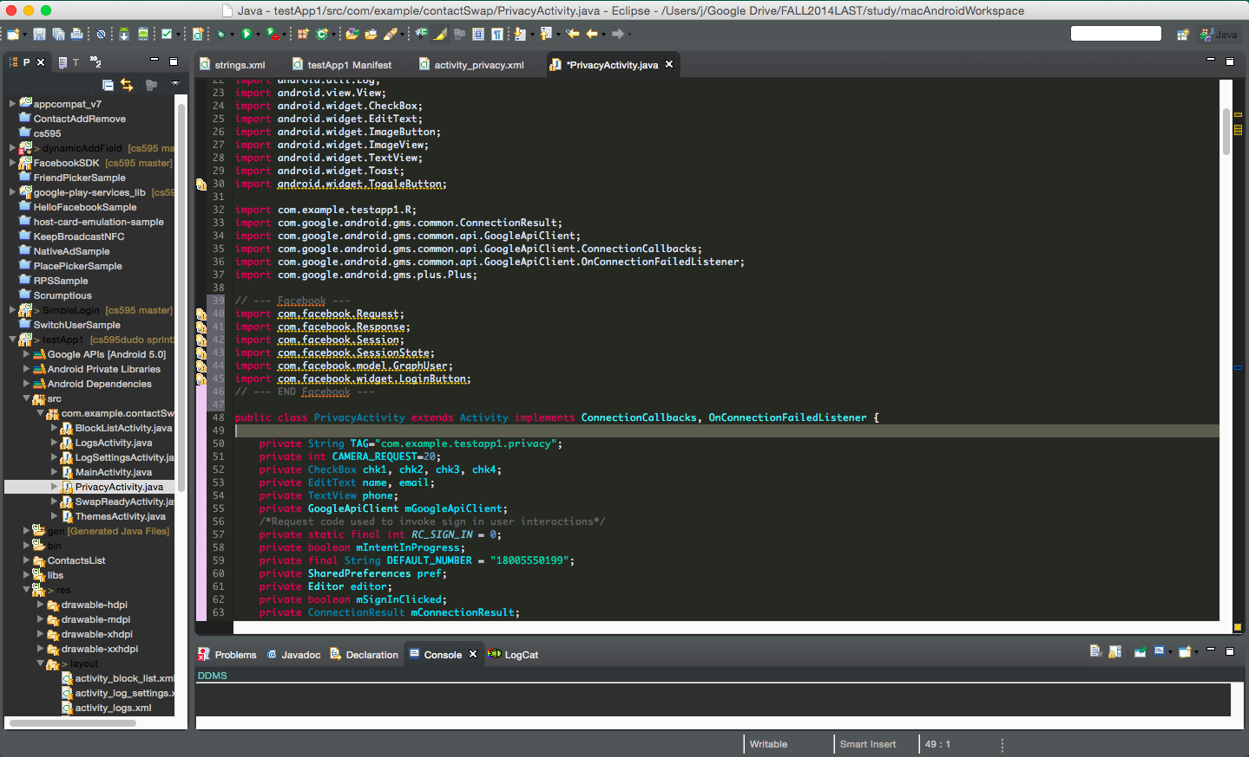

1. add private field, GraphUser stored facebook user info

private GraphUser graphUser;

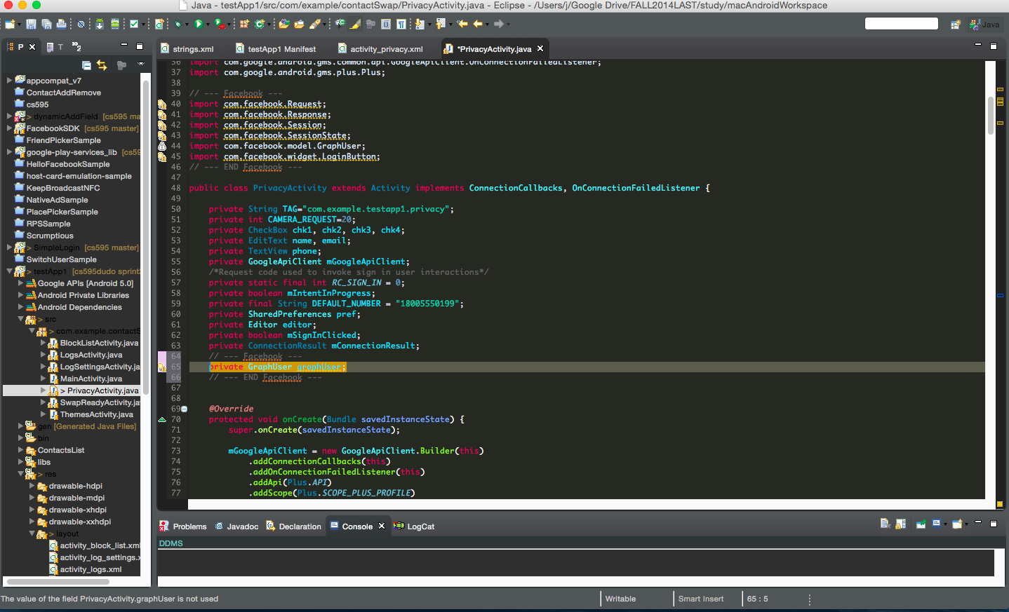

1. in OnCreate(), add this:

LoginButton authButton = (LoginButton) findViewById(R.id.authButton);

final Request.GraphUserCallback rgucb = new Request.GraphUserCallback() {

@Override

public void onCompleted(GraphUser user, Response response) {

if (user != null) {

// the user.getId is unique for every facebook user, If you got to the website : http://www.facebook.com/"user.getId()"

graphUser = user;

}

}

};

Session.StatusCallback sscb = new Session.StatusCallback() {

@Override

public void call(Session session, SessionState state, Exception exception) {

if (session.isOpened()) {

Request.executeMeRequestAsync(session,rgucb);

}

}

};

authButton.setSessionStatusCallback(sscb);

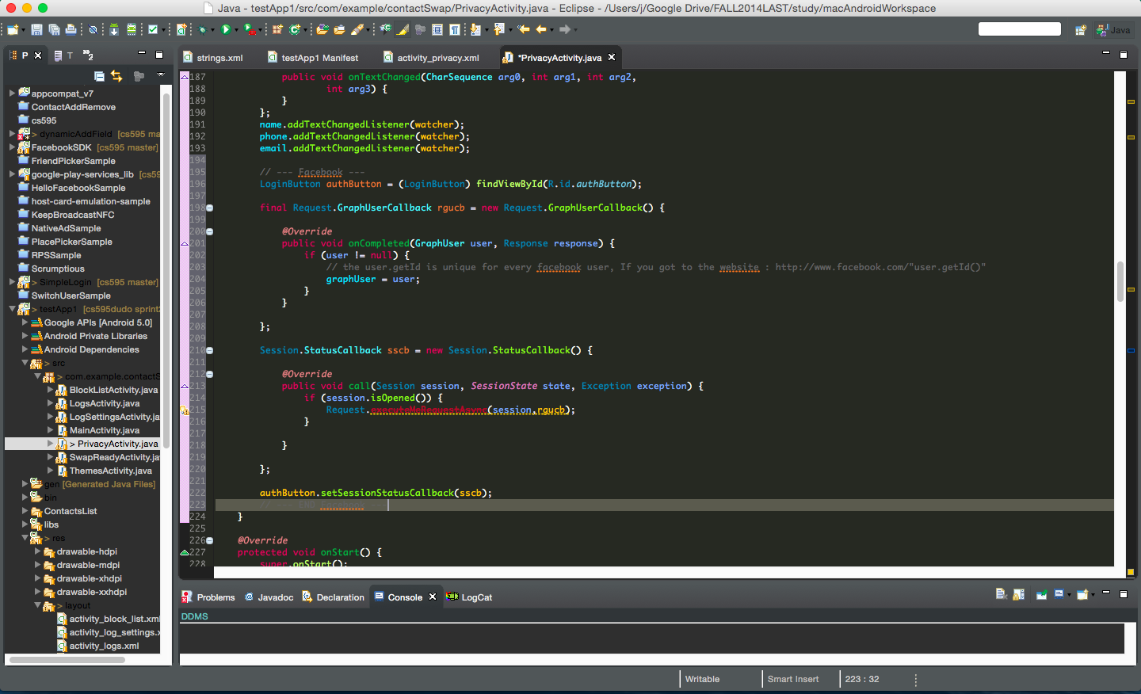

1. In onActivityResult(), add this :

Session.getActiveSession().onActivityResult(this, requestCode, resultCode, data);

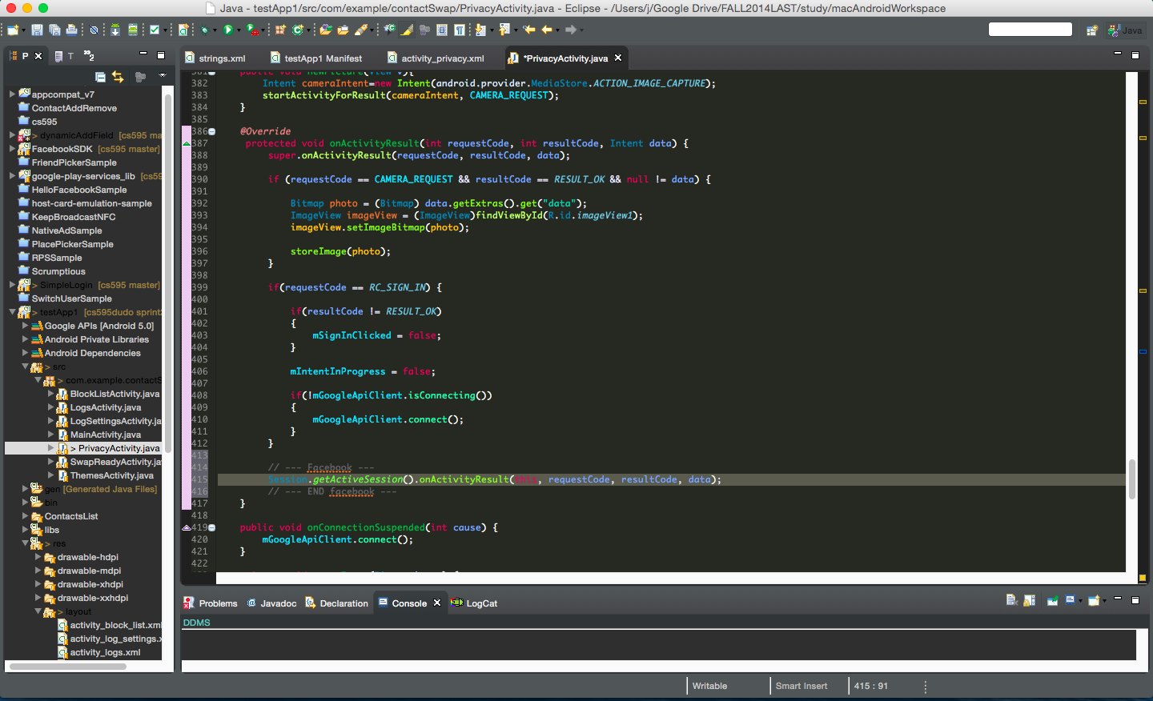

1. so now, graphUser will have facebook user info, just call graphUser.getId(), or graphUser.getFirstName() ,etc